Query the list of CITY names ending with vowels (a, e, i, o, u) from **STATION**. Your result cannot contain duplicates.

**Input Format**

The **STATION** table is described as follows:

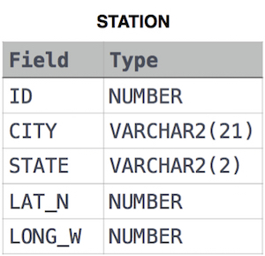

where LAT_N is the northern latitude and LONG_W is the western longitude.

Solution:

SELECT DISTINCT CITY

FROM STATION

WHERE LOWER(SUBSTR(CITY,LENGTH(CITY),1)) IN ('a','e','i','o','u');